Create a sample dataset and implement the below Pig commands on the same dataset.

1.CONCAT:used to concatenate two or more expressions of the same type.

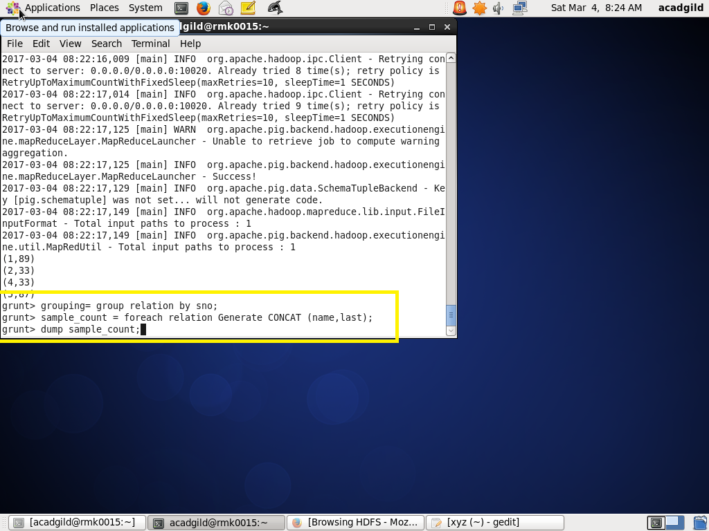

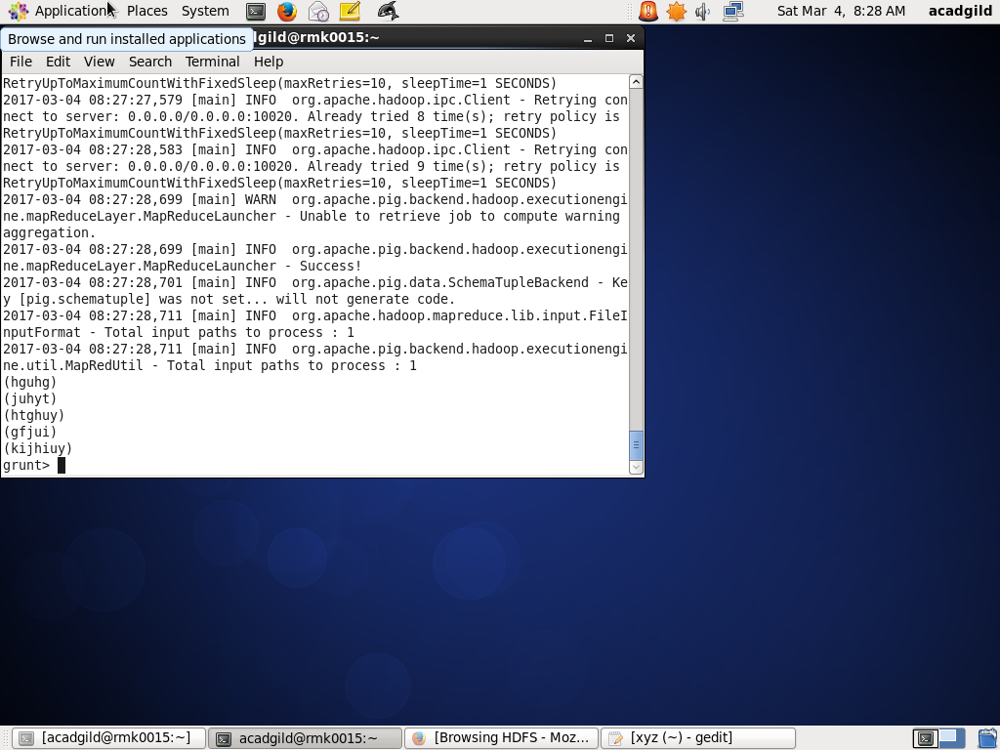

1. SUM: to get the total of numeric values of a column in a single-column bag

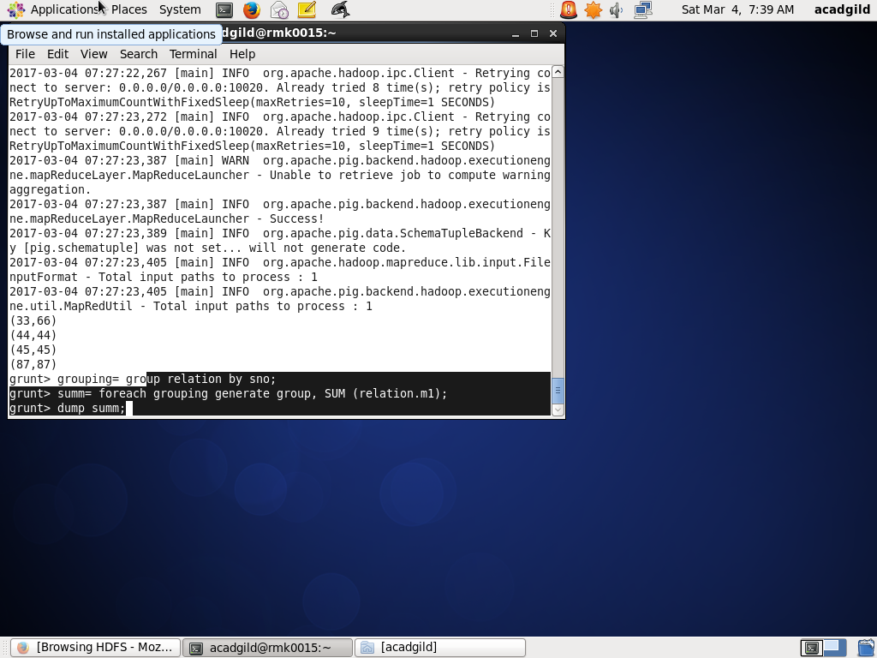

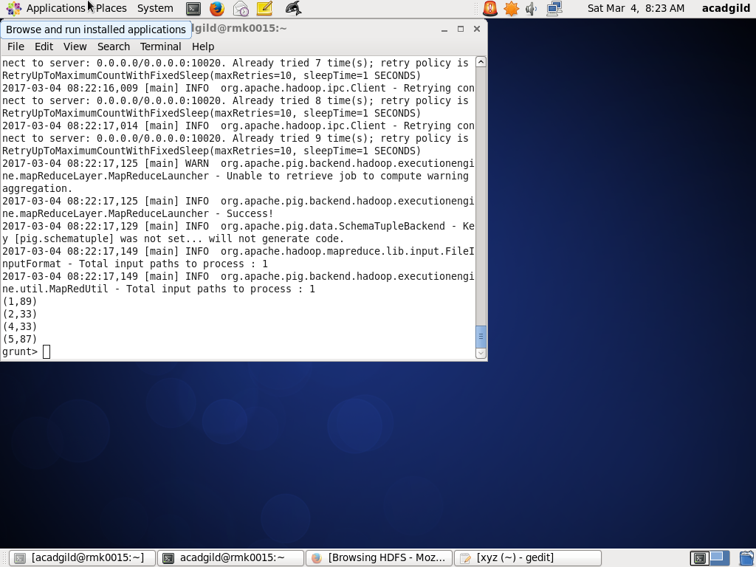

3) MIN: get minimum value for a certain column in a single-column bag.

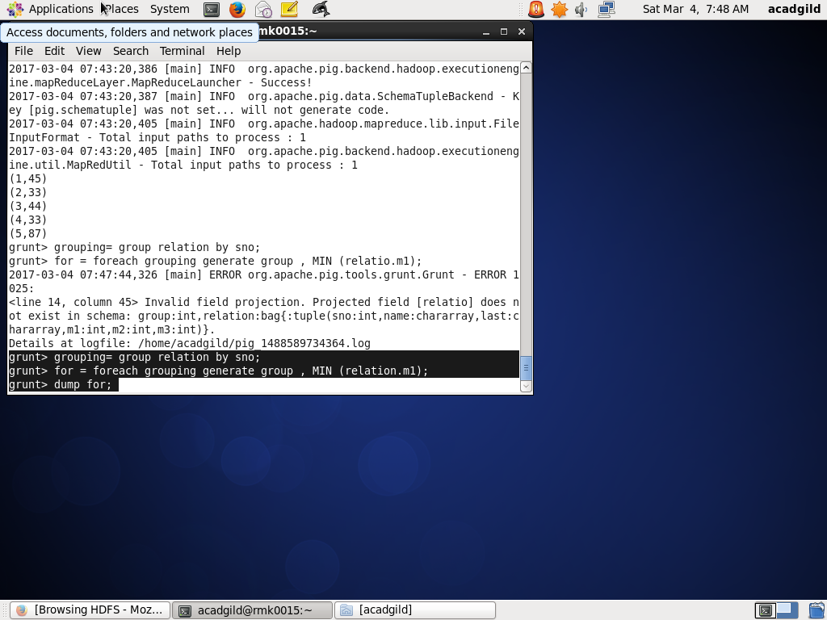

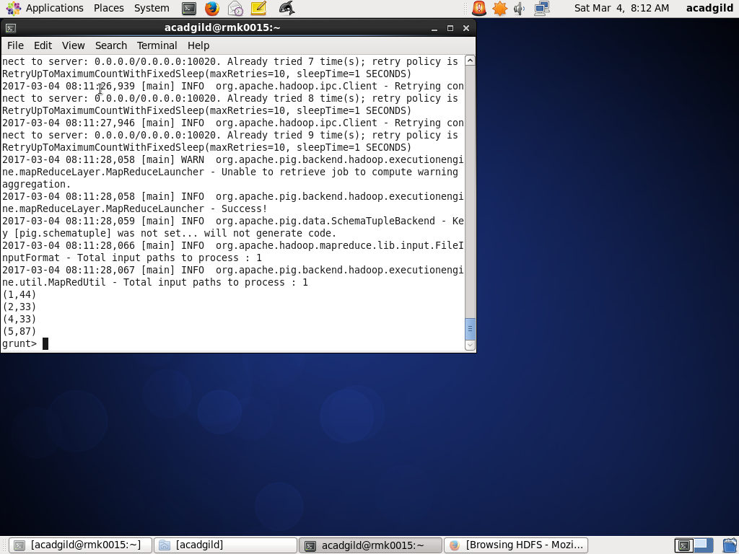

4) MAX: : get maximum value for a certain column in a single-column bag.

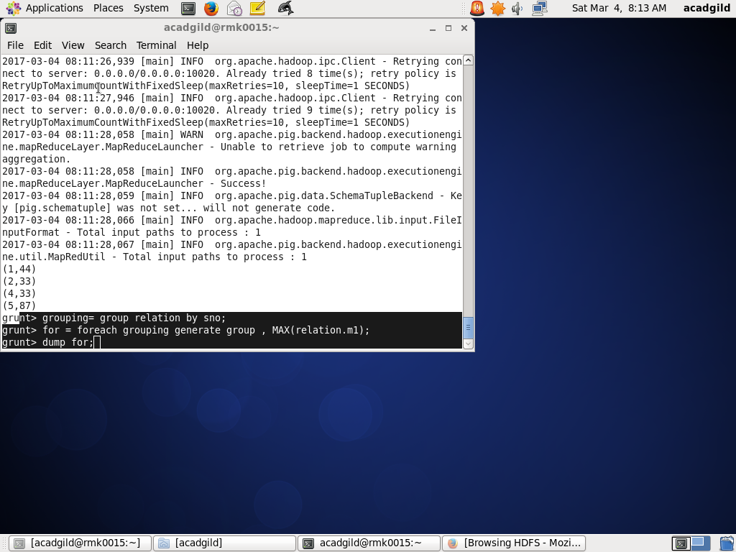

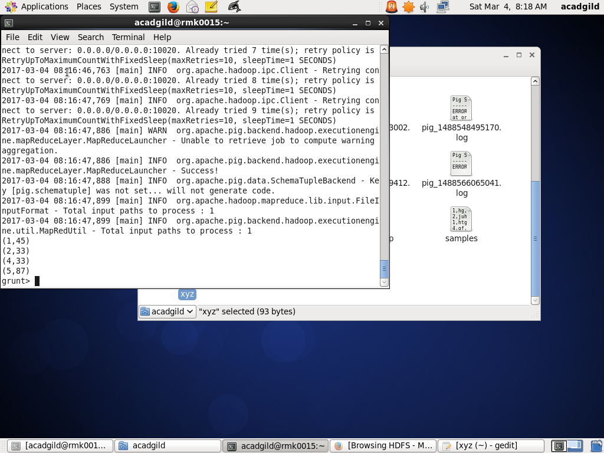

5) LIMIT: to get a limited number of tuples from a relation.

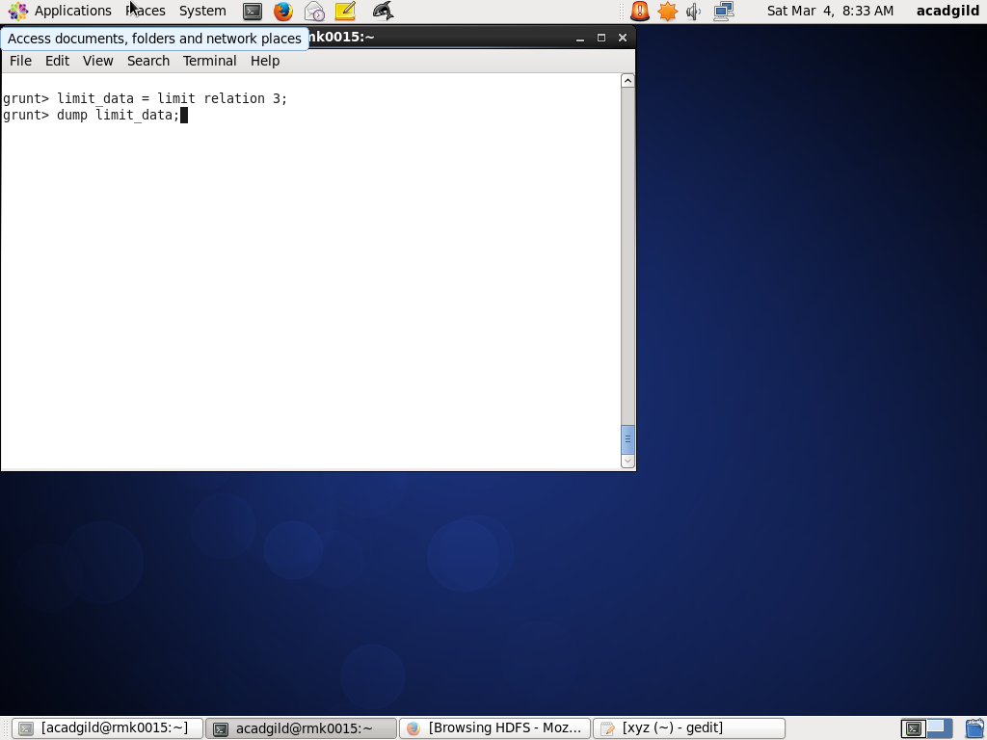

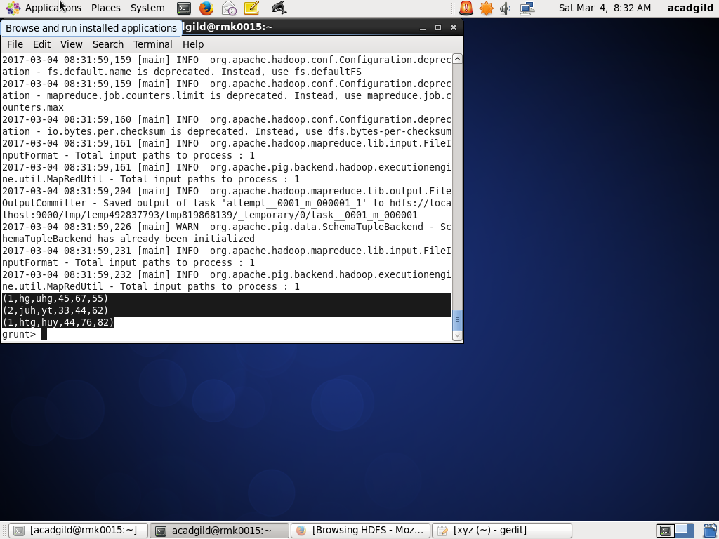

6) STORE : You can store the loaded data in the file system.

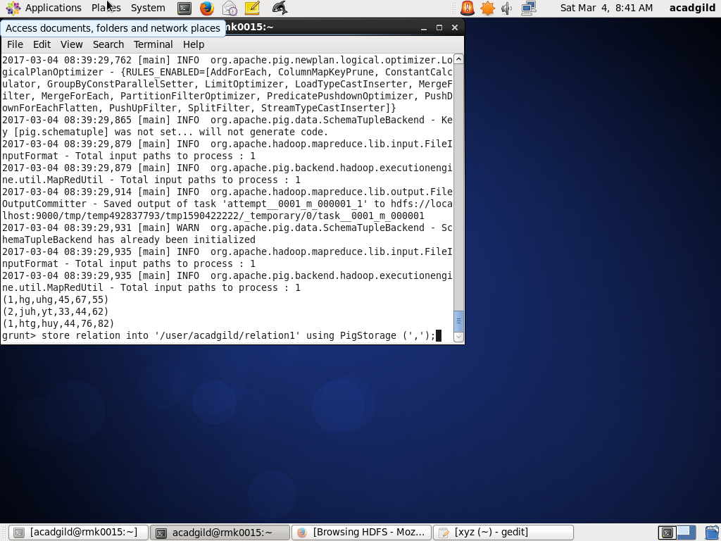

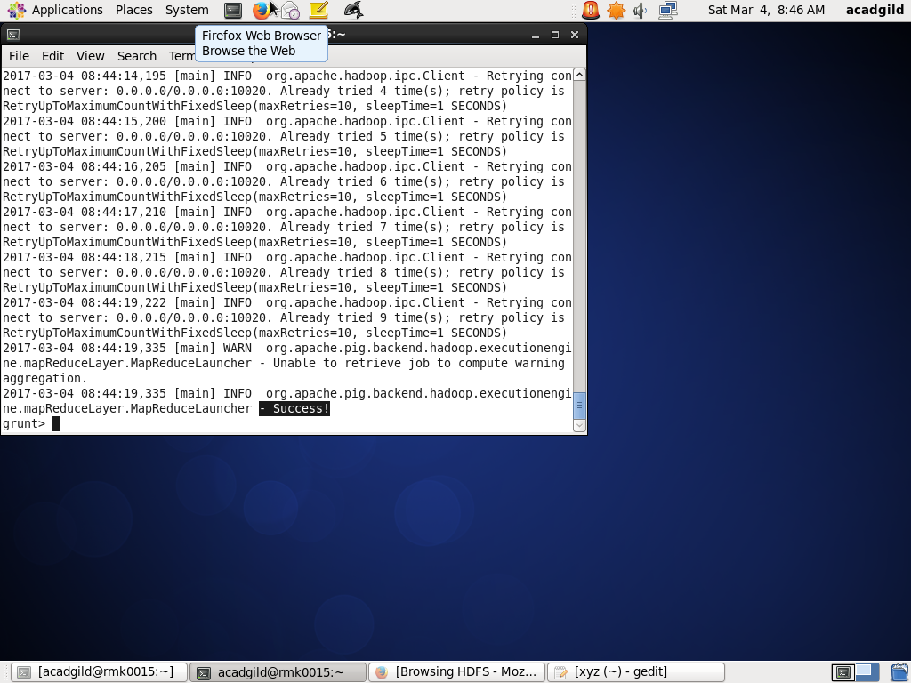

7) DISTINCT :  used to remove redundant tuples from a relation.

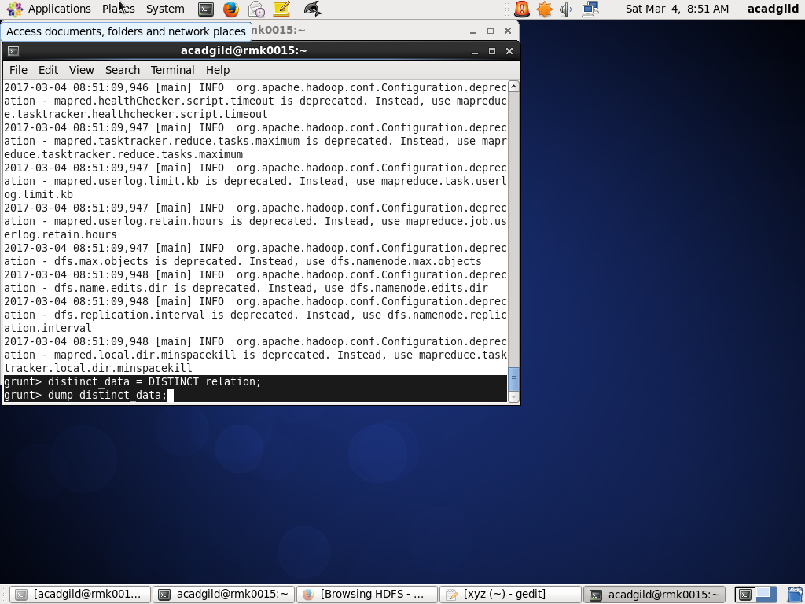

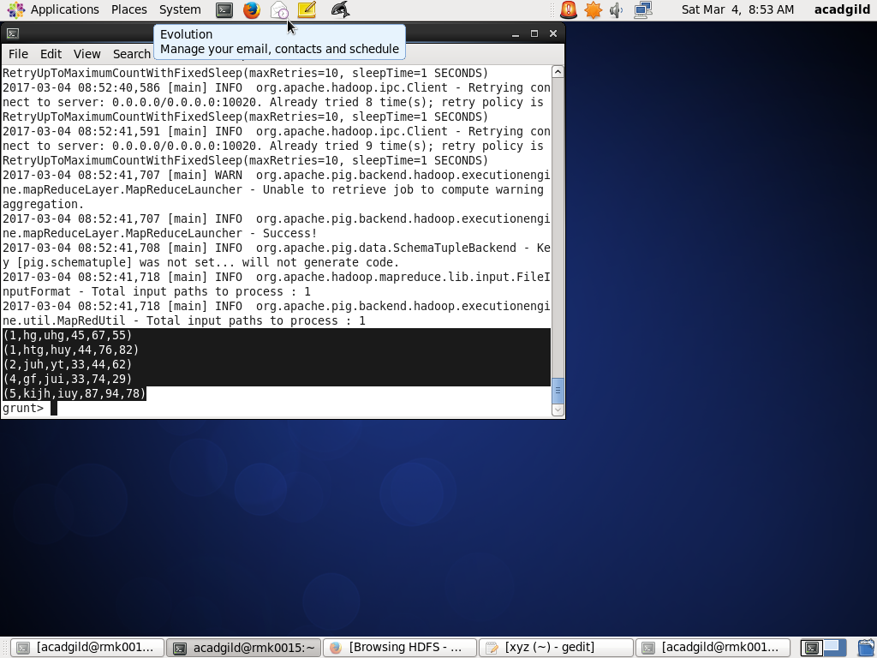

8) ISEMPTY : used to check if a bag or map is empty.

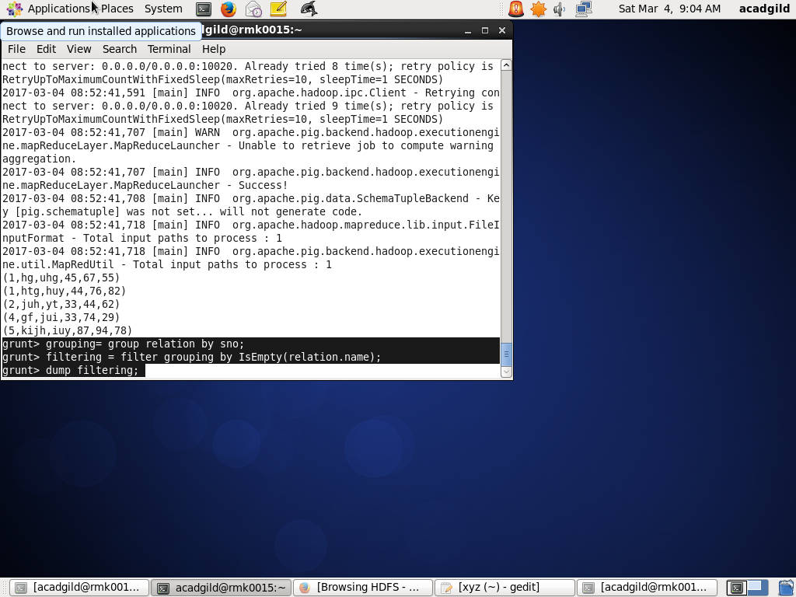

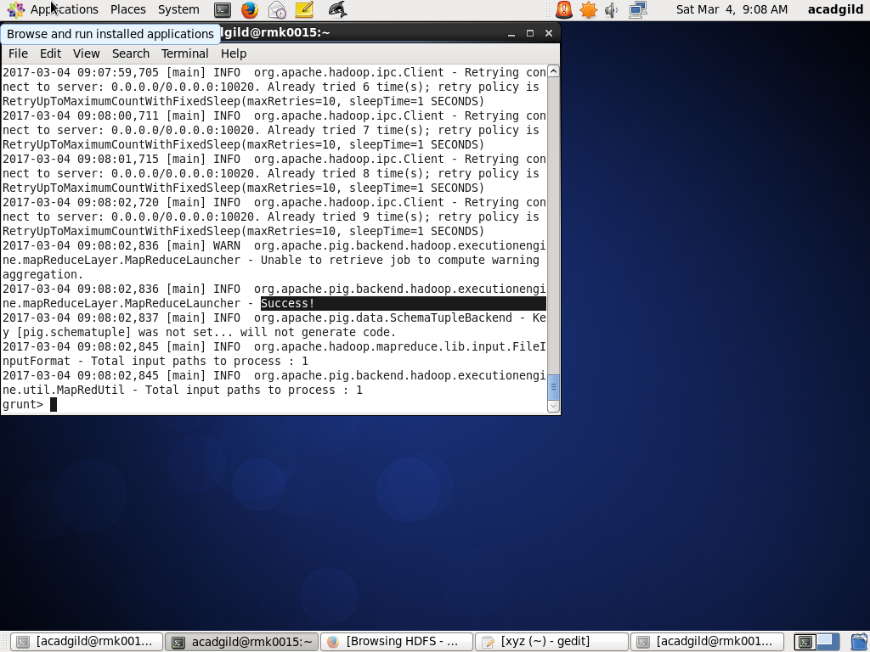

9)TOKENIZE :  used to split a string in a single tuple and returns a bag which contains the output of the split operation.

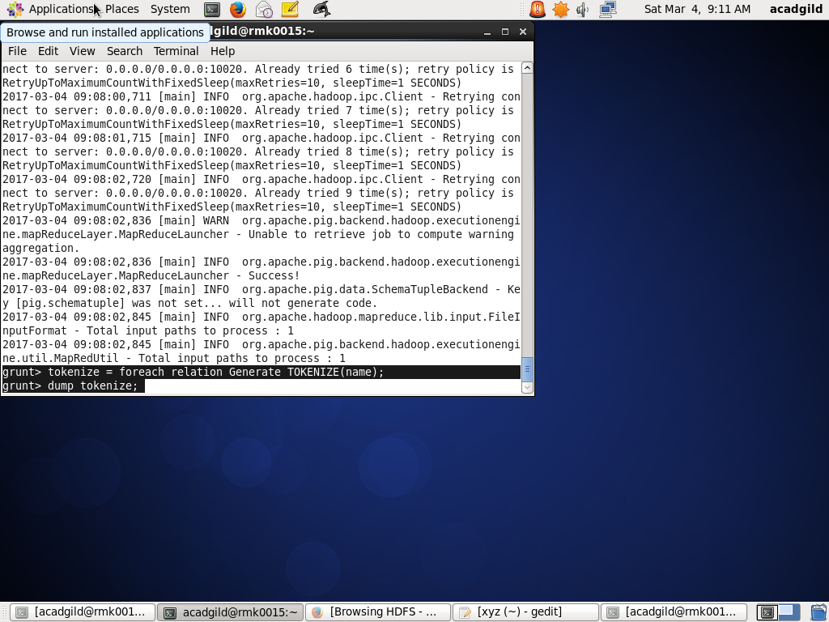

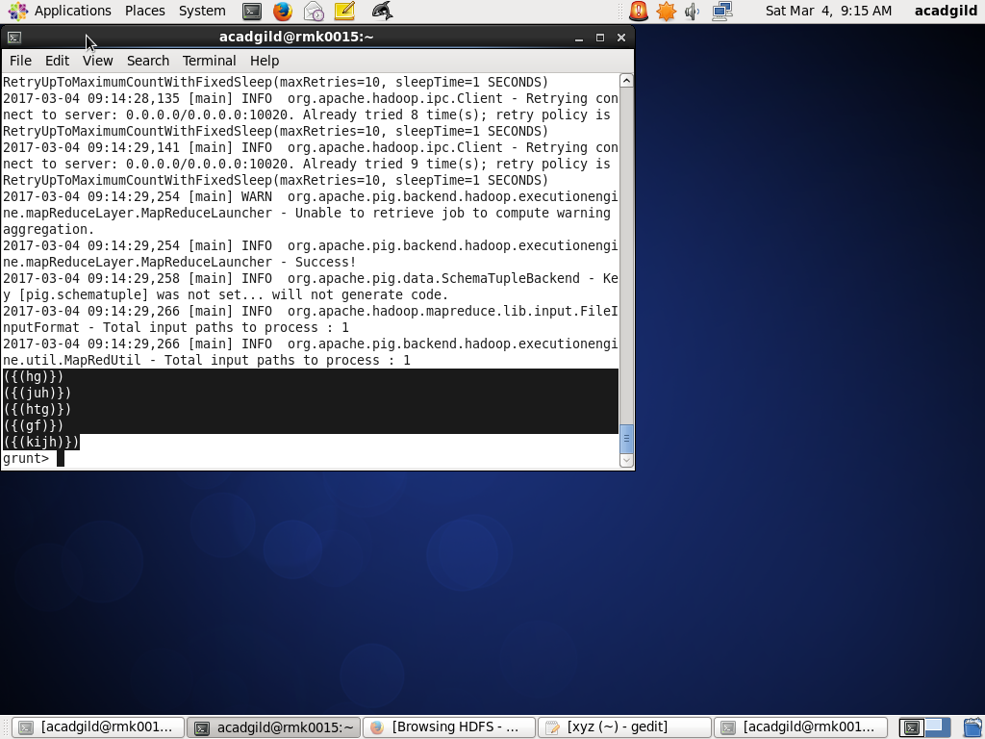

10) FLATTEN: an expression which will eliminate a level of nesting.

;

